Pre-Class:
- Create a YouTube account or log in to an existing account to test.
NOTE: you need to be logged into a You Tube account to send comments or messages during the live stream.
- Please Send documents that you would like to be remediated to Stateweb@admin.nv.gov so we can look at them after class (see conference line below).
Note: If you wish to practice remediating documents along with the instructor:
- Must have Adobe Acrobat Pro Series to be able to remediate PDF’s.
- Go to http://ada.nv.gov/Training/document_remediation/
- Select practice documents to download and remediate on your PC.

Live Stream Class:
- If you do not have a YouTube account, you will not be able to leave comments. Please call the conference line at the beginning, middle, or end of the course if you have questions.
- Go to the video settings and change resolution to 720p or 1080p (if available).
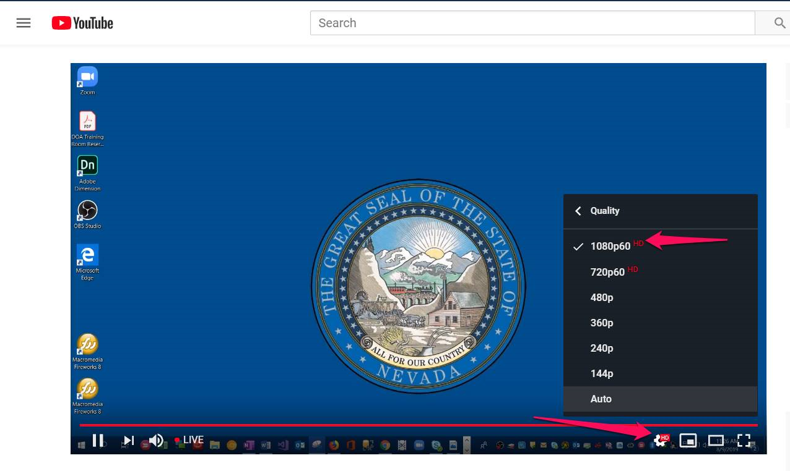

Conference Line:
- Please call at the end of class with the Conference Line 775-687-0999 Ext. 47310 for any questions about the course or to receive credit for the course if you do not have a You Tube account.
Did you Miss a Class?
If you did, please go to the Document Remediation Webinar:
https://www.youtube.com/watch?v=3Ify9mmuNNo&feature=youtu.be
Robert Shrader – stateweb@admin.nv.gov (775) 684-5852

