Live Stream Setup

Setting up to Live Stream with YouTube and OBS Encoder:

- Go to https://www.youtube.com/ and select the account that you are signed in to or create a new account.
- Select the profile icon in the upper right of YouTube.
- Select “YouTube (beta)” from the icon menu.
- In the bottom left pane select “Creator Studio Classic”
- Select “Live Streaming drop down arrow” from the Creator Studio pane.
- If you see the “Thanks for using YouTube Studio Beta!” Select Skip.
- Select “Live Streaming and then select “Events”
- Select “New live event” to create a new Live Stream event.
- Under “Basic info” give a new class title for the Live Streaming event
- Set the date and time of the new class.
- Give the new class a description of the course.
- Under “Advance settings” change Normal latency to Low-latency in the bottom right under “stream Optimizations.
- Select “Create Event”
- Select “Reusable Stream Key Drop down”.
- If you are setting up Live Streaming for the first time you must create a new stream.
- Select the stream that you created.
- Copy the “stream name code”.
- Download the OBS Encoder which will be used together with YouTube for Live Streaming.
- Open the OBS Encoder Select settings in the bottom right.
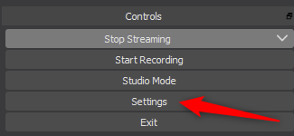
- Select Stream in the left pane.
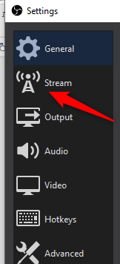
- Paste the “Stream Name Code” into the Stream Key field.
- Change the “Service drop down” to YouTube/ YouTube Gaming and Select Apply and OK.
- Go to Settings in the bottom right and select “Output” in the left pane and change “Video Bitrate” to 4500 kbps and Select Apply and OK.
- Go to Settings in the bottom right and select “Audio”. Make sure you have an audio device plugged in to your computer, so you have sound for your Live Stream. Select the Mic/Auxiliary Audio and select your audio device. Ensure that “Desktop Audio” is disabled to prevent background static and Select Apply and OK.
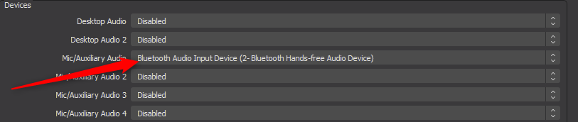
- To verify that you have sound enabled, you will see the Mixer bar on the main screen in OBS with the movement of the sound bar as you talk.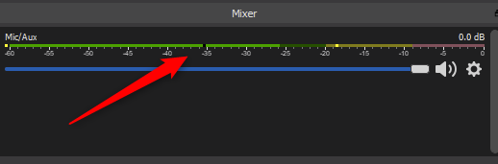

- Go to Settings in the bottom right and select “Video” in the left pane and change the “Base (Canvas) Resolution and the “Output (Scaled) Resolution to 1920x1080 and Select Apply and OK.
- Go to Settings in the bottom right and select “Advanced” in the left pane and change “Bind to IP” to [Ethernet 2] and Apply and OK.
- In the Sources pane you will have to select the + symbol and select “Display Capture” to view the screen that you will display in your Live Stream video.
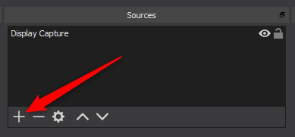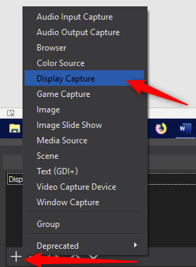
- Select “Events” in Creator Studio pane in YouTube.
- Click on the newly created video and copy the URL address in the top of the browser. This URL is the address to distribute to people so they can view your Live Stream Video.
Live Stream Instructions
- Go to https://www.youtube.com/ and select the account that you are signed in to.
- Select “YouTube (beta)”.
- In the bottom left select “Creator Studio Classic”
- If you see the “Thanks for using YouTube Studio Beta!” Select Skip.
- Select “Live Streaming drop down arrow” from the Creator Studio pane.
- Select “Events” and you will see the video that you have created for the Live Stream.
- Open up OBS Software and select “Start Streaming at the correct scheduled start time of Video stream”
- In YouTube select “Live Control Room” to the right of your video.
- Select “Preview” to sync up with the OBS Encoder.
- Once the Stream is synced up with the OBS Encoder you will be able to select “Start Streaming”. Select OK when you receive the “are you sure you want to start streaming the live event message.
- You are now Live Streaming.
- Once the class is done, Select Stop Streaming in the OBS Software application and then stop streaming in YouTube.
- You will find your video in the video manager and you can save it to your preferred playlist for future viewing.
If you have any questions about YouTube Live Streaming, please contact Stateweb@admin.nv.gov .

